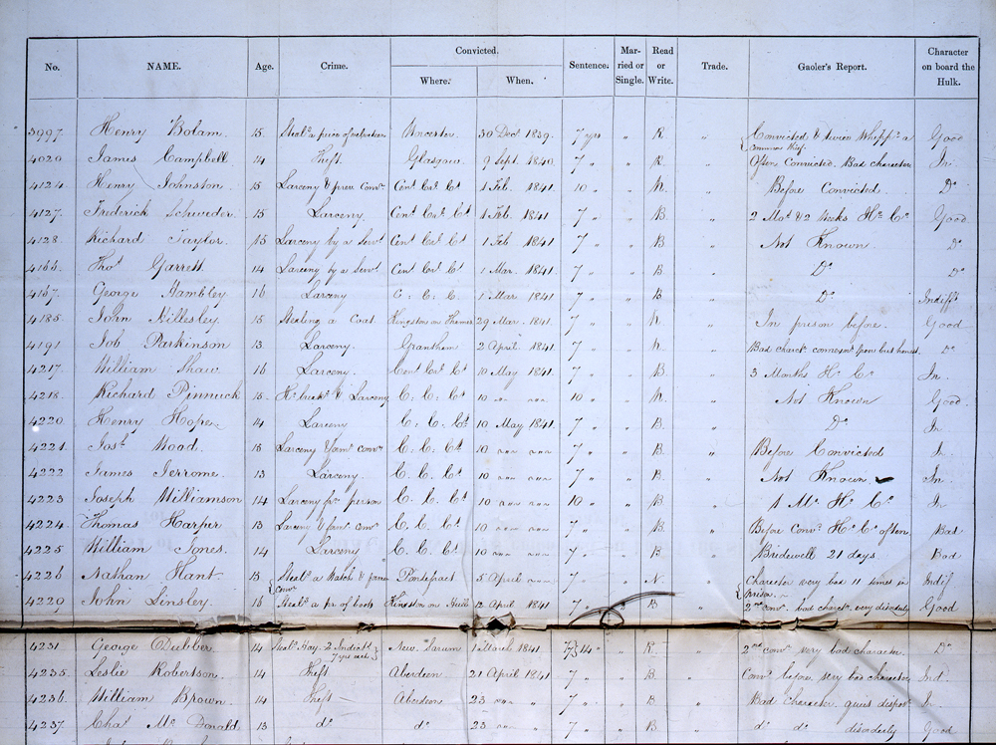
Transcript
No. | Name | Age | Crime | Convicted Where | Convicted When | Sentence | Married or Single | Read or Write | Trade | Gaoler's Report | Character on board the hulk
3997 | Henry Bolam | 15 | Steal[in]g a peice of Velveteen | Worcester | 30 Dec 1839 | 7 yrs | " | R | " | Convicted & twice Whipp[e]d a common thief | Good
4020 | James Campbell | 14 | Theft | Glasgow | 9 Sept 1840 | 7 " | " | R | " | Often Convicted. Bad Character | In
4124 | Jerty Johnston | 15 | Larceny & prev conv[iction] | Cen[tra]l Cr[imina[l] C[our]t | 1 Feb 1841 | 10 " | " | N | " | Before Convicted | Ditto
4127 | Frederick Schweder | 15 | Larceny | Cen[tra]l Cr[imina[l] C[our]t | 1 Feb 1841 | 7 " | " | B | " | 2 Mo[nth]s & 2 weeks H[ard] L[abour] | Good
4128 | Richard Taylor | 15 | Larceny by a Serv[an]t | Cen[tra]l Cr[imina[l] C[our]t | 1 Feb 1841 | 7 " | " | B | " | Not known | Ditto
4166 | Tho[ma]s Garrell | 14 | Larceny by a Serv[an]t | Cen[tra]l Cr[imina[l] C[our]t | 1 Mar 1841 | 7 " | " | B | " | Ditto | Ditto
4167 | George Hambley | 16 | Larceny | Cen[tra]l Cr[imina[l] C[our]t | 1 Mar 1841 | 7 " | " | B | " | Ditto | Indiff  [eren]t
4185 | John Hillesley | 15 | Stealing a Coat | Kingston on Thames | 29 Mar 1841 | 7 " | " | N | " | In prison  before | Good
4191 | Job Parkinson | 13 | Larceny | Grantham | 2 April 1841 | 7 " | " | N | " | Bad Charact[e]r co[?] poor but honest | Ditto
4217 | William Shaw | 16 | Larceny | Cen[tra]l Cr[imina[l] C[our]t | 10 May 1841 | 7 " | " | B | " | 3 Months H[ard] L[abour] | In
4218 | Richard Pinnuck | 15 | Ho[use] break[in]g & Larceny | Cen[tra]l Cr[imina[l] C[our]t | 10 ~"~ ~"~ | 10 " | " | N | " | Not known | Good
4220 | Henry Hooper | 14 | Larceny | Cen[tra]l Cr[imina[l] C[our]t | 10 May 1841 | 7 " | " | B | " | Ditto | In
4221 | Josh[ua] Mood | 15 | Larceny form[e]r conv[ictio]n | Cen[tra]l Cr[imina[l] C[our]t | 10 ~"~ ~"~ | 7 " | " | B | " | Before  Convicted | In
4222 | James Jerrome | 13 | Larceny | Cen[tra]l Cr[imina[l] C[our]t | 10 ~"~ ~"~ | 7 " | " | B | " | Not known | In
4223 | Joseph Williamson | 14 | Larceny from person | Cen[tra]l Cr[imina[l] C[our]t | 10 ~"~ ~"~ | 10 " | " | B | " | 1 M[onth] H[ard] L[abour[ | In
4224 | Thomas Harper | 13 | Larceny & prior conv[ictio]n | Cen[tra]l Cr[imina[l] C[our]t | 10 ~"~ ~"~ | 7 " | " | B | " | Before Convicted H[ard] L[abour] often | Bad
4225 | William Jones | 14 | Larceny | Cen[tra]l Cr[imina[l] C[our]t | 10 ~"~ ~"~ | 7 " | " | B | " | Bridewell 21 days | Bad
4226 | Nathan Hant | 15 | Steal[in]g a watch & former conv[ictio]n | Pontefract | 5 April ~"~ | 7 " | " | B | " | Character very bad 11 times in prison | Indif
4229 | John Linsley | 16 | Steal[in]g a pair of boots | Kingston on Hull | 12 April 1841 | 7 " | " | B | " | 2nd Conv[ictio]n. bad character very disorderly | Good
4231 | George Dubber | 14 | 2 Indict[ment]s 7 years each | New Sarum | 1 March 1841 | 7 7=14 " | " | R | " | 2nd Conv[ictio[n very bad character | Ditto
4235 | Leslie Robertson | 14 | Theft | Aberdeen | 21 April 1841 | 7 " | " | B | " | Conv[icte]d before. Very bad character | Ind
4236 | William Brown | 14 | Theft | Aberdeen | 23 ~"~ ~"~ | 7 " | " | B | " | Bad Character quite dishonest | In
4237 | Cha[rle]s McDonald | 14 | Ditto | Ditto | 23 ~"~ ~"~ | 7 " | " | B | " | ditto ditto disorderly | Good

