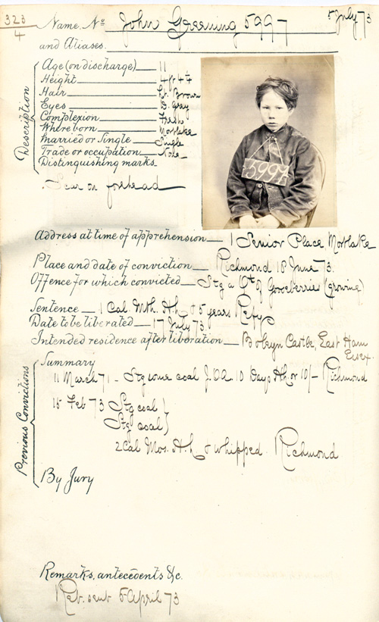
Transcript
Name No – John Greening 5997
and Aliases _______________
Description:
Age (on discharge) ________11
Height __________________4ft 4 1/4
Hair ___________________ Lt Brown
Eyes ___________________D Grey
Complexion _____________Fresh
Where Born _____________Mortlake
Married or Single _________Single
Trade or occupation ______ None
Distinguishing marks – Scar on forehead
Address at time of apprehension – 1 Senior Place, Mortlake
Place and date of conviction – Richmond 10 June 73
Offence for which convicted – Stealing a Quarter of Goosberries (growing)
Sentence – 1 Calendar Month Hard Labour & 5 years Reformitor]y
Date to be liberated – 17 Jult 73
Intended residence after liberation – Boleyn Castle, East Ham, Essex
Previous Convictions: Summary 11 March 71 – Stealing coal J.O.A. 10 Days Hard Labour or 10/- Richmond 1
5 Feb 73 Stealing coal
Stealing coal
2 calendar months Hard Labour & whipped
Richmond
By Jury
Remarks, antecedents &c
Rab. sent 5-April 73

