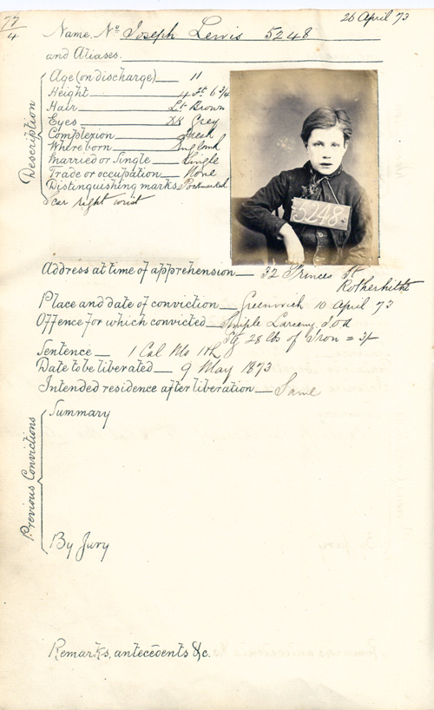

Transcript
Name No – Joseph Lewis 5248
and Aliases.___________________
Description
Age (on discharge) _____ 11
Height _______________ 4ft 6 3/4
Hair _________________ Lt Brown
Eyes _________________Dk Grey
Complexion ___________ Fresh
Where Born ___________England
Married or Single _______Single
Trade or occupation _____None
Distinguishing marks _____Pockmarked Scar rght wrist
Addres at time of apprehension – 32 Princess St Rotherhithe
Place and date of conviction – Greenwich 10 April 73
Offence for which convicted – Simple Larceny for stealing 28lb of Iron = 3/-
Sentence – 1 Calendar Month Hard Labour
Date to be liberated – 9 May 1873
Intended residence after liberation – Same Previous
Convictions:
Summary
By Jury
Remarks antecedents &c

